Day 1: Almaty
Your guide will meet you at the airport and transfer you to Almaty. You will visit the Green Bazaar, where it is impossible to refrain from shopping. Then the tour will continue in one of the oldest Almaty parks - Panfilov Park, where one of the most beautiful wooden building in the world - Zenkov Cathedral is located. After exploration of sport, cultural and business areas of the city you will get to the Medeo Gorge, well known due to the highest mountain skating rink in the world and Shymbulak resort. Next destination is the Kok-Tobe hill where the tallest TV tower in the world is located (if to count from the sea level) and where you will get by the picturesque winding mountain road. In Kok-Tobe Park you can stroll along the winding paths of the park, admire the magnificent panorama of the city from the special observation deck and visit the shop of national souvenirs. The tour ends with the short ride from the top of the hill to the center of the city by the famous Almaty cableway. Transfer to the hotel.

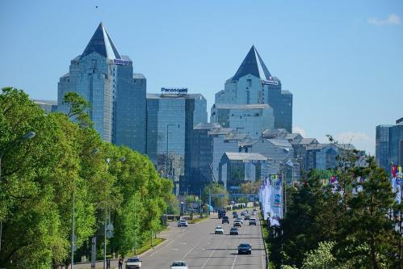
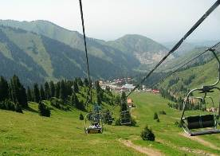

Day 2: Almaty – Charyn Canyon – Saty Village
Today you will have a day trip to Charyn Cabyons. It is one of the unique natural monuments of Kazakhstan. The canyon is about 12 million years old and surprises with its vertical cliffs, reminding the ancient castles, created by wind, sun and rain. It will take about 3 hours to reach the canyon. Meanwhile, you will hear a lot of interesting about the history and nature of the region, about Kazakh people, their life and traditions as well as have a lunch in a local cafe. In addition, as soon as you see Charyn Canyon you will forget about this long way at once - so much you will be impressed with the beauty and splendor of the canyon. You can admire the grand panorama and then have a walk through the maze of the Castles Valley with its inaccessible walls overhanging you. In the evening is transfer to Saty village.
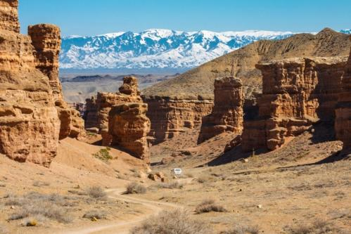
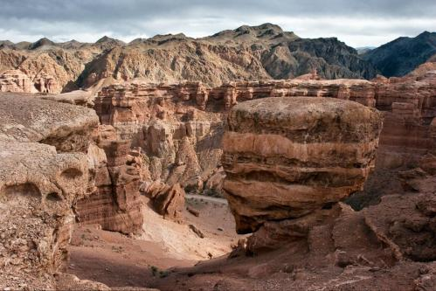

Day 3: Kolsai Lake
In the morning, you will have a trekking from the lake Kolsai-1 to the lake Kolsai-2. Lunch is on the way. Kolsai Lakes are "Pearls of the Northern Tien-Shan" - represent a cascade of three lakes. The largest lake is accessible for all visitors. It is the most beautiful lake, having a lack of civilization and the abundance of mushrooms. Horse lovers can order horseback tour to this place. The highest lake is small. It is located on the border of fir-wood and the alpine meadows and amazes by its harsh alpine beauty, as well as the rich flora and fauna. Vertical drop between the three lakes is about 700 meters. The lowest lake can be reached by car. However, you should walk few kilometers along mountain trails to see the second and the third lake. In addition, around mountains you can see Marals, mountain goats, wolves and even bears. Return to the guesthouse. Dinner. Overnight.
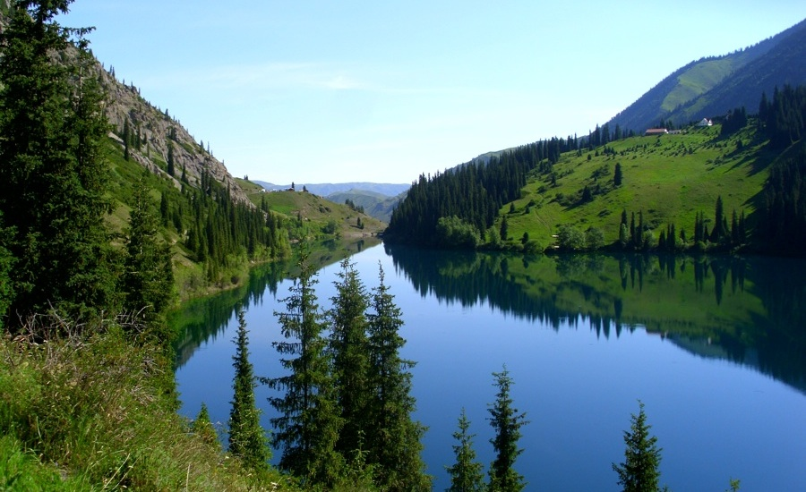
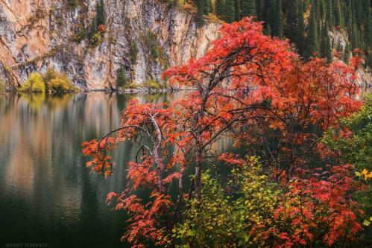

Day 4: Kolsai Lake – Kaindy Lake – Almaty
In the morning is transfer to Kaindy Lake. Kaindy Lake (Birch Lake) is situated among magnificent pine forest at an altitude of 2000 meters above sea level and is famous for its origin. It was formed in 1911 due to the powerful earthquake that triggered the landslide blocked the alley by the natural dam, and the water has flooded the valley. The water of the lake is very cold, that is why the needles of the flooded trees are well preserved and clearly visible through the transparent surface of the water, and dry stems of fir trees overlook the water surface, like the masts of the submarine squadron. It is impossible to describe in words all this mystical splendor of the lake – it is necessary to go there and see everything with own eyes. Arrival to Almaty is at 19:00. Overnight is in a hotel.
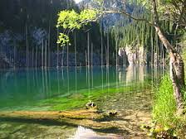
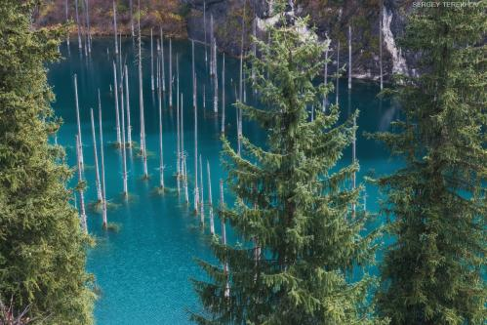

Day 5: Astana
In early morning, you will depart to Astana by flight. Meeting with the guide and transfer to the city (early check-in and breakfast are not included in the cost). Today you will see the Constitution Square, where the president of Kazakhstan N.A.Nazarbayev announced the decision of transferring the capital of the country from Almaty to Astana. You will visit the Presidential Centre of Culture of the Republic of Kazakhstan. At the museum, you will see the Golden man, well known not only in the Kazakh steppe but also in all Central Asia. In order to better understand today is life of the city; you will enter the largest and unique shopping center Khan Shatyr. Then you take the elevator to the top of the “Astana-Baiterek” monument, where you can admire the magnificent panorama of the Kazakhstan capital from the special observation deck. After lunch you will cross Ishym river and get to the Kazakh Eli Square. There you will visit another unique project - the Palace of Peace and Accord, and see the extraordinary beauty of Khazret Sultan mosque. Final point of the excursion will be the Palace of Independence, where you can look at the far-reaching plans of the development of Astana in the hall "Layout Astana until 2030". Transfer to the hotel.
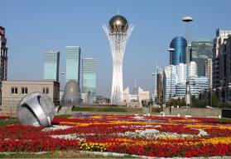
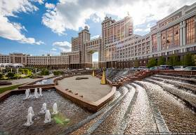
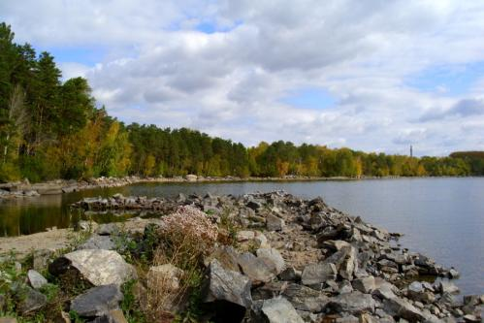

Day 6: Astana – Borovoe – Astana
Full day guided tour to Burabai National park (Borovoe), which occupies 85000 hectares of northeastern part of Kokshetau elevation. There are 14 lakes in the park, each having surface area of more than 1 sq.km, and a large number of small lakes. On a way to the resort area, which is in 270 km from Astana, the professional guide will introduce history of this region. On arrival, you will visit the Khan’s pass and see "Burabay" mountain. On Abylaykhan Valley, you will feast your eyes upon “Ush-kyz”, “Ok-Zhetpes”, “Zhumbaktas” rocks and “Kokshetau” mountain, each having the surprising legends reflecting history and identity of the Kazakh people. During the tour, you will have lunch in a local cafe and 30-minute free time to walk in the wood. Further you wil have an easy hiking on “Bolektau” mountain, on the top of which the tremendous view of the “Borovoe” lake and its surroundings opens. In the evening is transfer to the hotel.
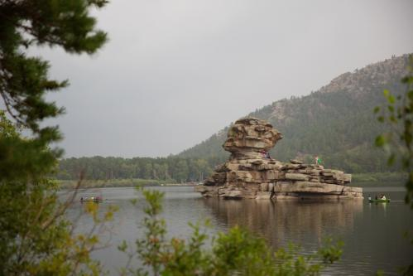

Day 7: Astana – Alzhir – Astana
It is an Akmola camp for the wives of traitors of Motherland - one of the largest camps of Soviet Union and one of the three "islands" of the "Gulag Archipelago". The exposition of the museum is located on hall perimeter that involves the visitor in a vicious circle and immerses in the historical past of Kazakhstan. At the end of excursion, you will watch 20-minute documentary film. After lunch, you will see the hunting with birds of prey is traditional for all Central Asian nomads. A rider with a golden eagle sitting on the wrist has always been a symbol of the Asian steppes. Falconry is practiced in many countries, but hunting with eagles on hares and foxes is an exceptional attraction of Kazakhstan. In Kazakhstan, hunters with eagles are called «Berkutchi». After demonstration of hunting, you will get a complete picture of the traditional hunting with eagles, which has far-historical roots. In the evening is transfer to the hotel.
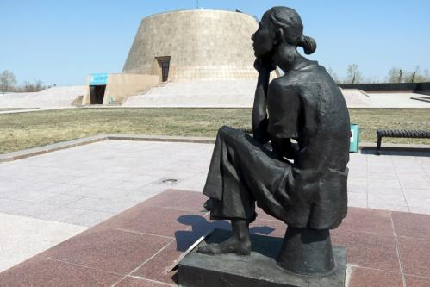
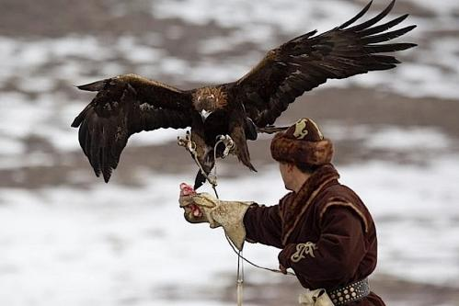

Day 8: Flight
Transfer to the airport.

Persons | Price per person in USD
Persons | Option A | Option B
2 | 1500 | 1610
4 | 1000 | 1110
6 | 785 | 895
8 | 670 | 780
10 | 595 | 710
10+1 Foc | 690 | 820
15+1 Foc | 675 | 805
20+1 Foc | 585 | 705
25+1 Foc | 535 | 665
30+1 Foc | 495 | 615
35+1 Foc | 485 | 600
40+1 Foc | 460 | 575
Single Supplement | 145 | 220
Early check in | 50 | 70
Early check in single | 70 | 100
HB | 125
FB | 185
Extra breakfast on 3rd day | 15
Flight Almaty-Astana | 110 (price approximate, depend of purchasing day)

Cities | Nights | Option A | Option B
Almaty | Three | Kazakhstan 3* | Kazzhol 4*
Astana | Three | Ibis 3* | Kazzhol 4*
Satty village | Two | Home Stay (wc outside of home)

Price includes:
- Accommodation at mentioned hotels on double share basis
- Transportation per program in comfortable a/c transport with professional drivers
- Breakfasts at the hotels
- Lunches on days 2,3,4
- Dinners on days 2, 3
- Daily two bottles of 0.5l water per person
- Group tour leader in single room on Foc base (+1 Foc)
- Escort English speaking guide
- Entrance fees to mentioned sights per program (excluding photo and video charges at sights)

Price does not include:
- Visa consular fees and processing expenses
- Visa support to Kazakhstan
- Photo and video charges at sights
- International air tickets to / out of Almaty
- Travel Insurance
- Extras, not indicated in inclusions

PS:
- Pricing valid for contracted partners only for mentioned dates
- If mentioned hotels are overbooked or not available, we will give appropriate alternative.
- If there are more than 20 people, the hunter cannot demonstrate the hawk hunting show.

Payment:
- Tour payment should be made not less than 40 days prior to tourist group arrival to our bank account as per sent invoice.
- The rooming list should be finalized 30 days before arrival.

Cancellation fees:
- No charges up to 45 calendar days up to tour starting date
- 50% of full package price up to 14 calendar days up to tour starting date
- 100% of full package price – 7 or less working days up to tour starting date or no show.

